**Design Portfolio**

**By:**

**Net 1 Bier**

**Randolph Bock 25905570**

**FJ Fourie 26047799**

**Anton Durandt 25645013**

Submitted in pursuit of the degree

**BACHELOR OF ENGINEERING**

**In**

**COMPUTER AND ELECTRONIC ENGINEERING**

**North-West -University Potchefstroom Campus**

Supervisor: Prof J. Holm

Potchefstroom

August 31, 2017

**Contents**

1 System Operational Requirements 1

1.1 Functional Analysis – Operational Level Architecture and Behaviour 1

1.2 Physical Requirements (Form): 2

1.3 Interface requirements(Fit): 2

1.4 Aditional Requirements: 3

2 Excel Project management 4

3 Engineering Methods/Skills/Tools: 4

3.1 Randolph Bock 4

3.2 Anton Durandt 4

3.2.1 Scope of work: 4

3.2.2 Assumptions and constrains: 5

3.3 FJ Fourie 5

4 Sub-system specification DOCUMENTS: 6

4.1 Randolph Bock 6

4.1.1 Sub-system functional Analysis 6

4.1.2 Sub-system Interface Definitions 6

4.2 Anton Durandt 7

4.2.1 Sub-system functional Analysis 7

4.2.2 Sub-system Interface Definitions 7

4.3 FJ Fourie 7

4.3.1 Sub-system functional Analysis 7

4.3.2 Sub-system Interface Definitions 7

5 Design Documentation: 7

5.1 System Design Documaentation 7

5.1.1 Final System Functional Definition: 7

5.1.2 System concept drawings: 7

5.1.3 System interface Definitions: 8

5.1.4 System integration testing: 10

5.2 Sub-system Design Documentation Randolph Bock: 10

5.2.1 Technology Survey/Datasheets 10

5.2.2 Application Notes 10

5.2.3 Trade off Studies 10

5.2.4 Design Drawings: 11

5.2.5 Behavioural Modelling 11

5.2.6 Design implementation: 11

5.2.7 Sub-system Test and Evaluation: 11

**List of Figures:**

Figure 1: System Operational Architecture 1

Figure 2: System Operational Flow 2

**List of Tables:**

# 1 System Operational Requirements

## 1.1 Functional Analysis – Operational Level Architecture and Behaviour

1.1.1 System Operational Architecture:

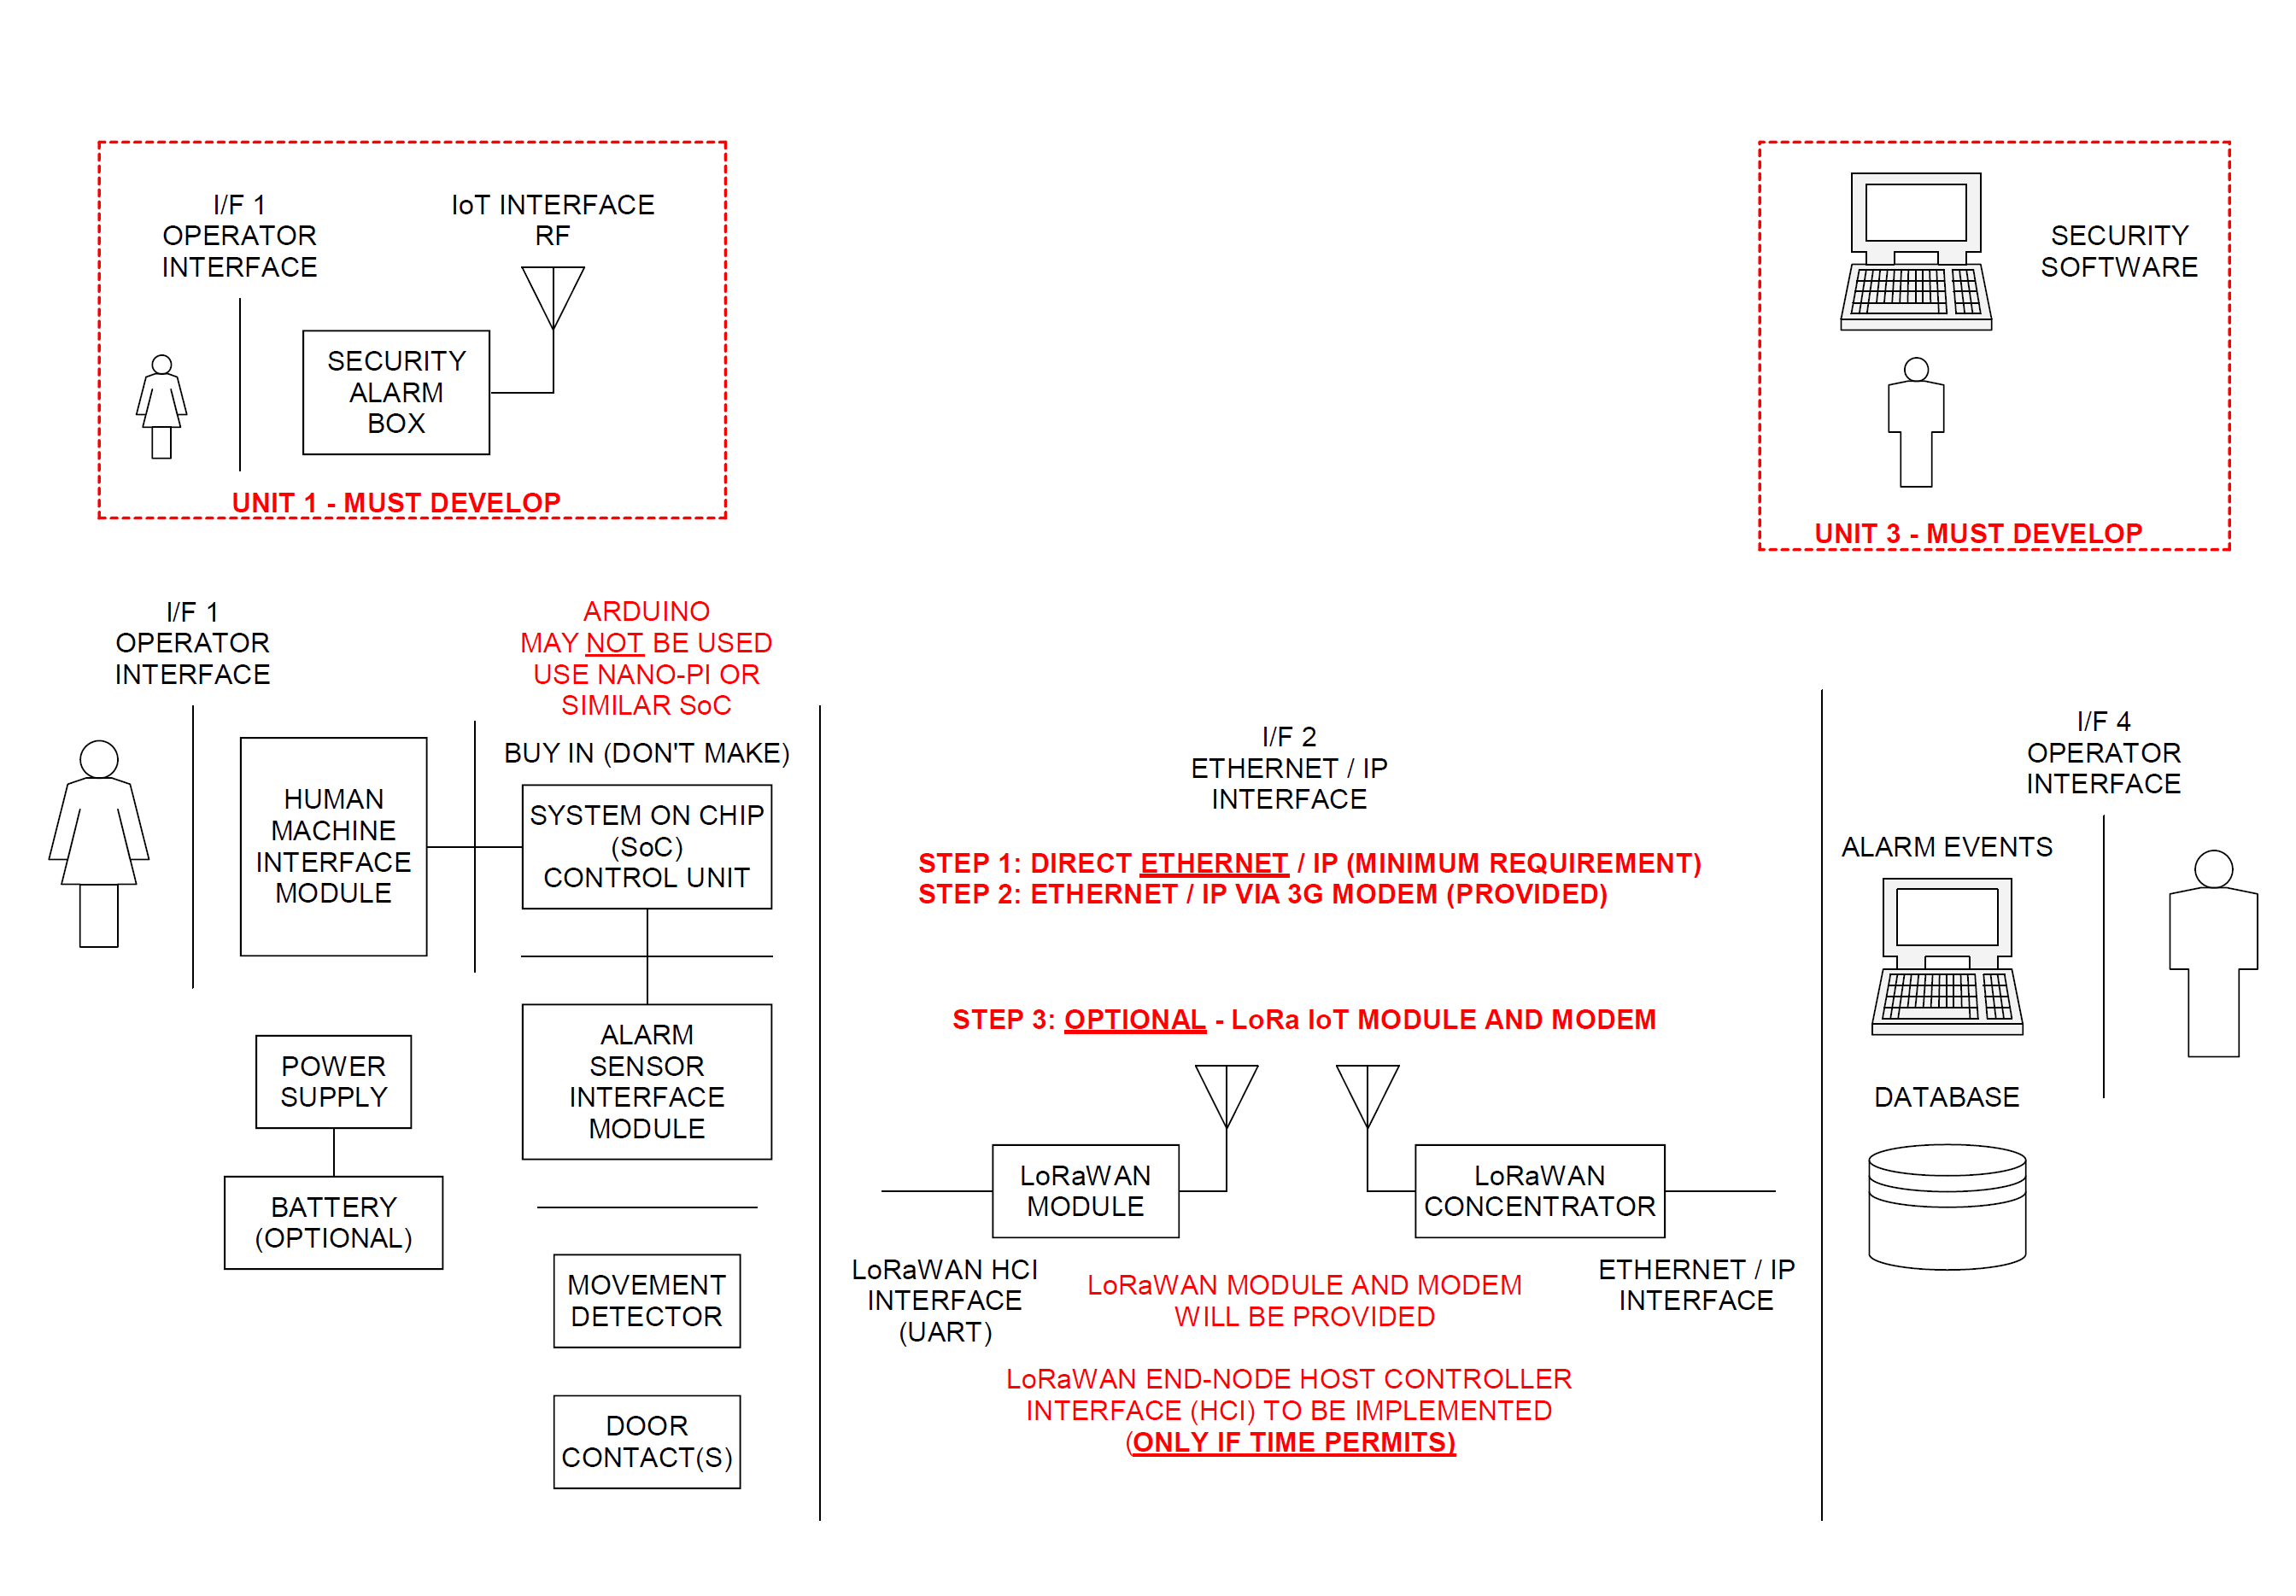

Figure : System Operational Architecture

1.1.2 System Operational Flow:

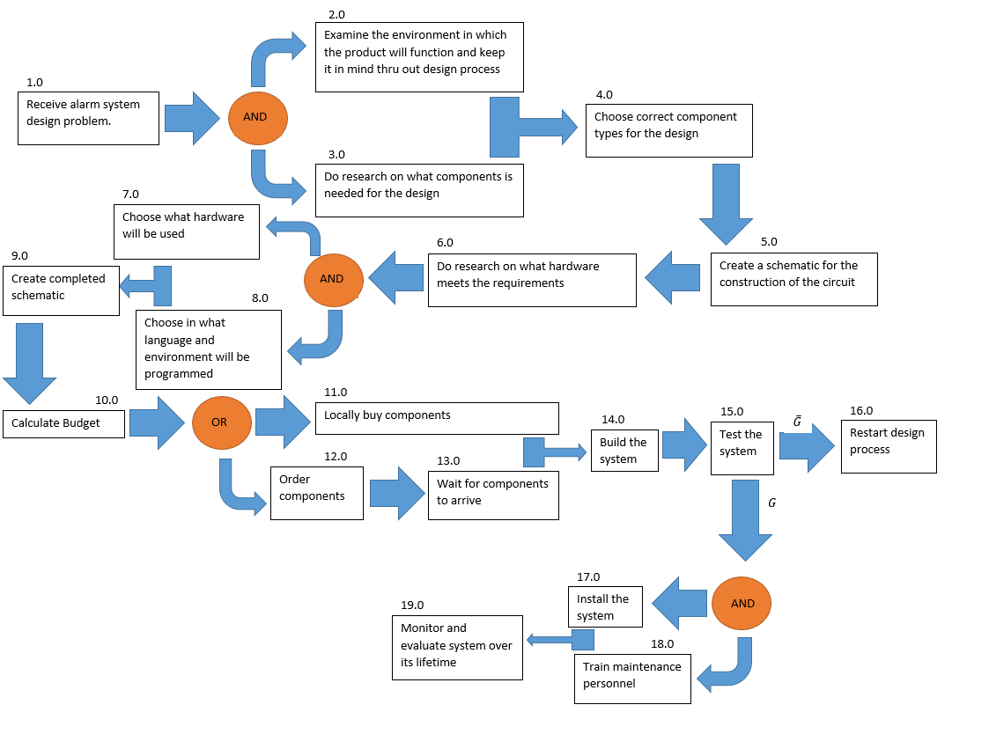

Figure : System Operational Flow

## 1.2 Physical Requirements (Form):

* The alarm panel as well as any sensors of the system must be IP54 rated.
* The alarm panel must be wall mountable
* The alarm panel must allow for wires to enter the panel without damaging the wires

## 1.3 Interface requirements(Fit):

* The interface between the end user and the alarm will be both audio and visual, and be easily understandable
* All items on the functional architecture must be developed, apart from PIR and other sensors
* The single board computer (SBC) will be a Raspberry Pi
* The database server will initially be hosted on a laptop or student PC. Later implementation should be in the cloud, but cloud implementation is not a prerequisite to pass the module. However, clear proof must be provided that the database and monitoring software on the PC has been designed by following the design process
* An output will be provided to the Power Block to show that motion has been detected on an “outdoor sensor”
* The input power to the Alarm Panel will be provided from the Power Block and will be 12V at a maximum of 6W
* The Alarm Panel will provide its own internal voltages for the SBC and other components
* The IoT link will be a transparent GSM link that replaces the Ethernet. LoRaWAN can be used at the end of the project if time allows
* The interface between the incoming power and the internal power supply of the system will be a two-wire interface, positive and negative wire, to be connected to the system with screw in wire terminals.
* The placement on the wall cannot be too high as it will make it difficult for users to access the panels
* The placement cannot be to low either as it may become a risk for small children
* The placement should not be over pre-existing water pipes or wiring in the wall

## 1.4 Aditional Requirements:

1.4.1 Environmental Requirements:

* The alarm panel as well as any sensors of the system must be IP54 rated
* Will be made reasonably tamper proof
* Will be made from strong material to endure some wear
* The system must be protected against Electro Static Discharges, ESD.

1.4.2 Safety requirements

* The system will be grounded to ensure no electrical shocks can occur to an end user
* No open wires
* Not accessible to children
* No places where people can get shocked
* Closed box so that people who do not understand the device cannot tamper with it
* Reasonably tamper proof

1.43 Legislative Requirements (SAIDSA bylaw 25)

* Control equipment
  + Control panel installed min of 1.5 m form ceiling
  + Digital keypads must be of the data transfer technology type
  + Disarming delay no more than 30 seconds
* Signalling equipment
  + Signalling equipment will be positioned within the protected area
  + Not placed where telephone lines are vulnerable
* Maintenance
  + Inspect and test each detection device back to control panel
  + Inspecting alarm panel and transmitter
  + Inspect cables for visible damage

1.4.4 Usability Requirements:

* System must be easily operated with minimal training required to operate the system
* Compensation for mounting will be made for the control box

# 2 Excel Project management

Se additional document: Design 2017 - Project Management - Net 1 Bier .xlsx

# 3 Engineering Methods/Skills/Tools:

## 3.1 Randolph Bock

See additional Document: Design 2017 - Randolph ELO5 - Net1Bier.docx

## 3.2 Anton Durandt

### 3.2.1 Scope of work:

* Design and implement a Direct ethernet / IP connection between SoC and Pc
* Design and implement an ethernet / IP connection via 3g between SoC and Pc

### 3.2.2 Assumptions and constrains:

* Time constraint for use of LoRaWAN

## 3.3 FJ Fourie

See additional Document: Design 2017 - FJ ELO5 - Net1Bier.docx

# 4 Sub-system specification DOCUMENTS:

## 4.1 Randolph Bock

### 4.1.1 Sub-system functional Analysis

### 4.1.2 Sub-system Interface Definitions

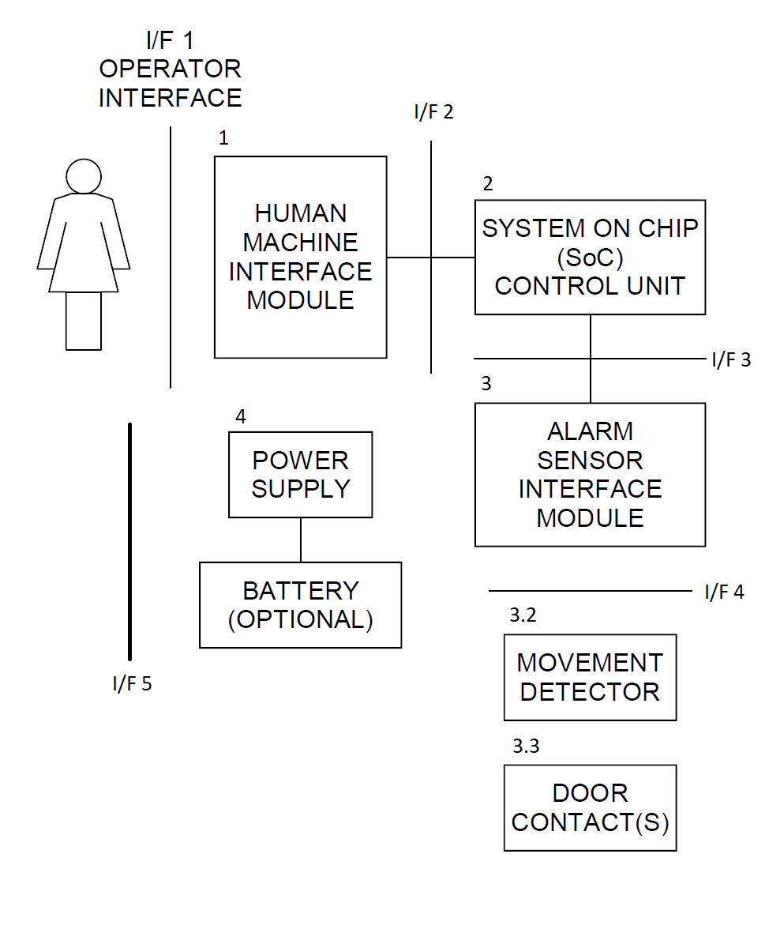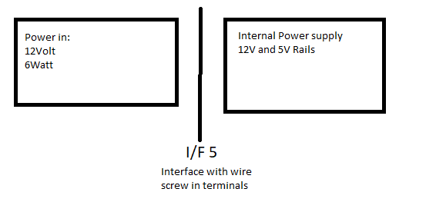

## 4.2 Anton Durandt

### 4.2.1 Sub-system functional Analysis

### 4.2.2 Sub-system Interface Definitions

## 4.3 FJ Fourie

### 4.3.1 Sub-system functional Analysis

### 4.3.2 Sub-system Interface Definitions

# 5 Design Documentation:

## 5.1 System Design Documaentation

### 5.1.1 Final System Functional Definition:

### 5.1.2 System concept drawings:

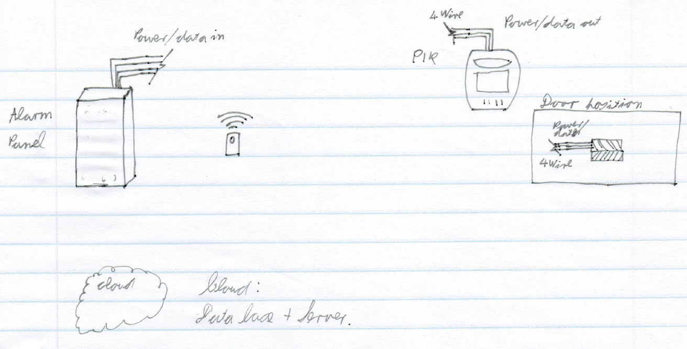

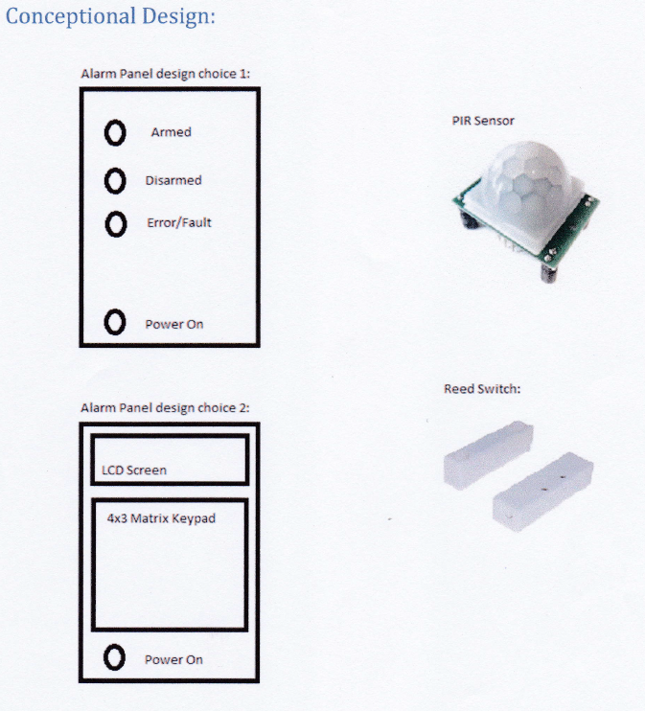

### 5.1.3 System interface Definitions:

**Interface control document (I/F 5)**

This interface control document is the interaction between the power block and the alarm.

I/F 5

Power block

Alarm Panel

**Electrical requirements**

The power block will provide 12 V and 6 W power to the alarm panel.

**Mechanical requirements:**

The mechanical interface will be a two-point screw terminal for both sides so that a wire can be connected between the two.

This document was signed in Potchefstroom on the date 2017/09/4 as an agreement between the EERI327/ INEM327 and REII327 students in regard to the power supply to the alarm panel. This document is binding until the end of the 3rd year design module 2017.

Representatives

_________________________________

**C.F. Greyling**

_________________________________

**FJ Fourie**

Witnesses

_____________________________

**Witness 1**



_________________________________

**Witness 2**

### 5.1.4 System integration testing:

## 5.2 Sub-system Design Documentation Randolph Bock:

### 5.2.1 Technology Survey/Datasheets

### 5.2.2 Application Notes

### 5.2.3 Trade off Studies

|  |  |  |  |  |  |
| --- | --- | --- | --- | --- | --- |
| **Visual Human Machine interface (I/F 1):** | | | |  |  |
|  | **LCD Screen** | **LED's** | **7-Segment** |  | **Weight** |
| **Cost** | 3 | 10 | 7 |  | 0,5 |
| **Reliability** | 6 | 9 | 7 |  | 0,3 |
| **Ease of use** | 6 | 7 | 6 |  | 0,2 |
|  | 4,5 | 9,1 | 6,8 |  |  |
|  |  |  |  |  |  |
| **Input Human Machine interface (I/F 1):** | | | |  |  |
|  | **Remote** | **Turn key** | **Keypad** |  | **Weight** |
| **Cost** | 1 | 5 | 9 |  | 0,5 |
| **Reliability** | 2 | 2 | 8 |  | 0,3 |
| **Ease of use** | 7 | 9 | 6 |  | 0,2 |
|  | 2,5 | 4,9 | 8,1 |  |  |
|  |  |  |  |  |  |
| **5V Voltage regulator** | |  |  |  |  |
|  | **LM7805** | **LM371** | **usb1002** |  | **Weight** |
| **Efficiency** | 3 | 4 | 8 |  | 0,5 |
| **Cost** | 8 | 8 | 7 |  | 0,2 |
| **Reliability** | 7 | 8 | 9 |  | 0,3 |
|  | 5,2 | 6 | 8,1 |  |  |

### 5.2.4 Design Drawings:

### 5.2.5 Behavioural Modelling

### 5.2.6 Design implementation:

### 5.2.7 Sub-system Test and Evaluation: